》 Introduction to Oracle Database

[https://docs.oracle.com/cd/E11882_01/server.112/e40540/intro.htm#CNCPT001](https://docs.oracle.com/cd/E11882_01/server.112/e40540/intro.htm" \l "CNCPT001)

An Oracle database server consists of a database and at least one database instance (commonly referred to as simply an instance)

A database is a set of files, located on disk, that store data. These files can exist independently of a database instance.

Database instanceDatabase

An instance is a set of memory structures that manage database files. The instance consists of a shared memory area, called the system global area (SGA), and a set of background processes. An instance can exist independently of database files.

Database Instance Structures： Instance Memory Structures，Oracle Database Processes

Database Storage Structures：Physical Storage Structures，Logical Storage Structures

Application and Networking Architecture：Application Architecture，Networking Architecture

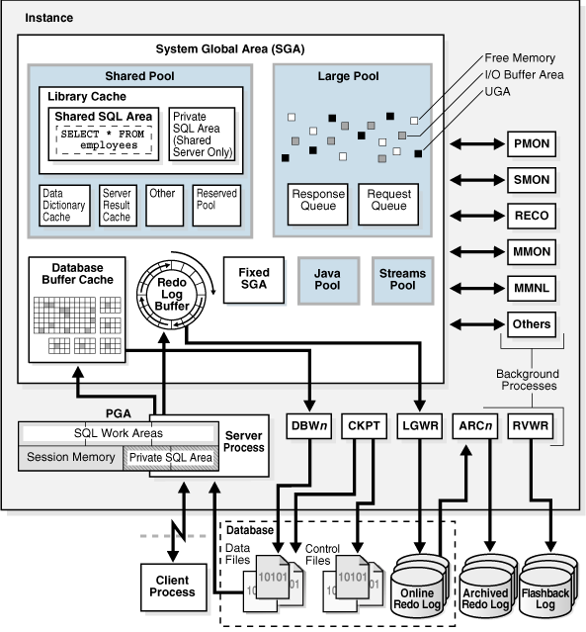

深入理解体系结构不仅有助于了解Oracle数据库的运行机制，还可以在故障发生时帮助大家快速

的定位问题的根源所在

--叶节点，叶节点，叶节点......

--》叶节点》枝干》根

学习不能 管中窥豹可见一斑，应该做到窥一斑而知全豹

面试题！

sqlplus sys/sys@test

create table test_archi(id number primary key,name varchar2(22),salary number);

insert into test_arch values(1,'lili',10000);

update test_arch set salary='20000' where id=1;

commit;

alter system switch logfile;

===============================

》Memory Architecture

When an instance is started, Oracle Database allocates a memory area and starts background processes

内存中放置了哪些东西呢？

Basic Memory Structures

System global area (SGA)

The SGA is a group of shared memory structures, known as SGA components

Program global area (PGA)

A PGA is a nonshared memory region that contains data and control information exclusively for use by an Oracle process.

Database initialization parameters set the size of the instance PGA, not individual PGAs

User Global Area (UGA)

The UGA is memory associated with a user session.

Software code areas

Oracle Database code is stored in a software area that is typically at a different location from user programs—a more exclusive or protected location.

Oracle Database Memory Management

Automatic memory management-AMM

定义一个内存总大小，redistributing memory as needed between the SGA and the instance PGA.

Automatic shared memory management-ASMM

You set a target size for the SGA and then have the option of setting an aggregate target size for the PGA or managing PGA work areas individually.

Manual memory management-MMM

you set many initialization parameters to manage components of the SGA and instance PGA individually

9i>10G>11G

11g

If you create a database with Database Configuration Assistant (DBCA) and choose the basic installation option, then automatic memory management is the default.

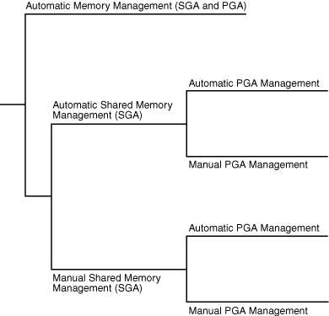

Overview of the User Global Area

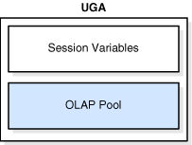

Overview of the Program Global Area

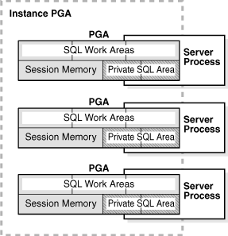

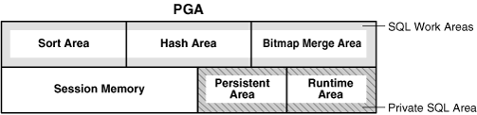

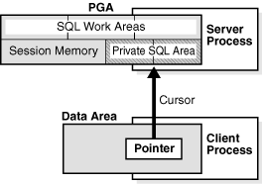

A cursor is a name or handle to a specific private SQL area

In general, applications should close all open cursors that will not be used again to free the persistent area and to minimize the memory required for application users.

Overview of the System Global Area

SQL> STARTUP

ORACLE instance started.

Total System Global Area  368283648 bytes

Fixed Size                  1300440 bytes

Variable Size             343935016 bytes

Database Buffers           16777216 bytes

Redo Buffers                6270976 bytes

Database mounted.

Database opened.

The most important SGA components are the following:

Database Buffer Cache

Redo Log Buffer

Shared Pool

Large Pool

Java Pool

Streams Pool

Fixed SGA

Database Buffer Cache

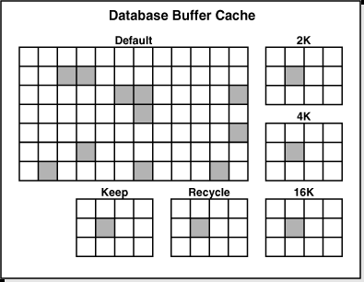

goals：优化物理io，将常用的buffer保存在内存中

Buffer States：Unused，Clean，Dirty

Every buffer has an access mode: pinned or free (unpinned). A buffer is "pinned" in the cache so that it does not age out of memory while a user session accesses it. Multiple sessions cannot modify a pinned buffer at the same time. ==热快》buffer pin latch》buffer busy wait

Buffer Modes：Current mode（db block get）=block，Consistent mode（consistent read get）=undo

Statistics

----------------------------------------------------------

      1  recursive calls

      0  db block gets

      0  consistent gets

      0  physical reads

      0  redo size

    530  bytes sent via SQL*Net to client

    523  bytes received via SQL*Net from client

      2  SQL*Net roundtrips to/from client

      0  sorts (memory)

      0  sorts (disk)

      1  rows processed

Buffer I/O

Buffer Writes

The database writer (DBW) process periodically writes cold, dirty buffers to disk. DBWn writes buffers in the following circumstances:

1 A server process cannot find clean buffers for reading new blocks into the database buffer cache.

least recently used (LRU) list》cold 》write queue》dbw1，dbw2.。。。。

2 The database must advance the checkpoint, which is the position in the redo thread from which instance recovery must begin.

3 Tablespaces are changed to read-only status or taken offline.

Buffer Reads：

cache hit：logical read

cache miss：physical read》logical read

The database re-uses each clean buffer as needed

cache hit远远快于cache miss》buffer cache hit ratio越高越好

Buffer Touch Counts

LRU list using a touch count.When a buffer is pinned, the database determines when its touch count was last incremented

three-second rule：If the count was incremented over three seconds ago, then the count is incremented; otherwise, the count stays the same》避免计数虚高

新buffer放在LRU列表中间》通过touch counts不断调整在LRU列表中的位置》那些常用的计数高的buffer会移动到热端，不常用的计数底的buffer会移动到冷端

如果一个buffer到达LRU的冷端末尾，其计数较高，会移动到LRU热端末尾

Note:

The database does not physically move blocks in memory. The movement is the change in location of a pointer on a list.

Buffers and Full Table Scans

full table scan：reads all rows under the table high water mark

如果表的总大小大于buffer cache，会导致清空buffercache，阻止数据库管理哪些常用的数据块》避免full table scan

为了有效的利用buffer cache，全表扫描后的buffer可立即重用

Buffer Pools：A buffer pool is a collection of buffers

Default pool

Keep pool

Recycle pool

nK buffer pool 》 传输表空间

alter system set db_16k_cache_size=500M scope=both;

create tablespace DATA01 datafile '/u01/app/oracle/oradata/ora10g/DATA01_01.dbf' size

256M uniform. size 4M blocksize 16K;

Redo Log Buffer

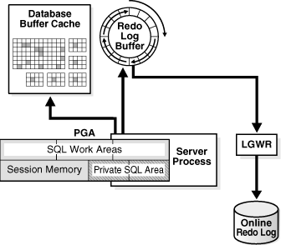

sequential writes：LGWR

Scattered writes：DBWn

sequential writes>Scattered writes

Oracle允许LGWR不等待DBWn完成，提供了更好的性能

The LOG_BUFFER initialization parameter specifies the amount of memory that Oracle Database uses when buffering redo entries. Unlike other SGA components, the redo log buffer and fixed SGA buffer do not divide memory into granules.

Shared Pool

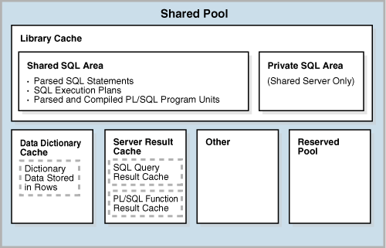

Library Cache

soft parse=library cache hit

hard parse=library cache miss

Shared SQL Areas：parse tree and execution plan.

Private SQL area：

数据库自动分辨类似的sql语句，包括直接发出的sql和递归sql

1 检查语法、语义相同的sql是否在共享池中，如果有soft parse，减少cpu和内存资源，没有则hard parse

2 私有sql区只有在共享连接模式下才会存在

Allocation and Reuse of Memory in the Shared Pool

LRU list

内存不够时，会清理shared sql area，即使这个sql被经常使用，下次使用时会重新做hard parse

下列情况会清除shared sql area

1 table, table cluster, or index收集统计信息后，会逐步移除这些对象相关的shared sql area，以反应新的统计信息变化，产生最优的执行计划

2 sql语句引用的对象，执行了ddl操作，需要重新硬解析

3 更改了global database name，数据库会清空共享池

Data Dictionary Cache：对象（表，视图。。）的定义，权限等

row cache：数据字典信息以行的形式缓存而不是buffer

Server Result Cache

SQL query result cache：运行同一 SELECT 语句，有了结果缓存，可以避免重复读数据块和计算结果的昂贵代价

使用注释提示/*+RESULT_CACHE*/ 来告诉数据库缓存哪个sql的结果集

PL/SQL function result cache

Reserved Pool

为了使分配大于5k大小空间更有效，使用保留池

Large Pool

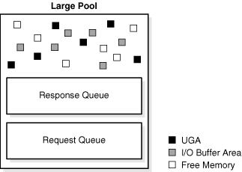

大型池不适用LRU list，内存被占用直到使用完才释放

UGA for the shared serve

Oracle XA

RMAN I/O

parallel execution of statements

Java Pool

The Java pool is an area of memory that stores all session-specific Java code and data within the Java Virtual Machine (JVM)

Streams Pool

The Streams pool is used exclusively by Oracle Streams.

Fixed SGA

The size of the fixed SGA is set by Oracle Database and cannot be altered manually.

show parameter memrory

show parameter sga

show parameter pga

show parameter area

show parameter log_buffer

select * from v$sgainfo;

select pool,sum(bytes) from v$sgastat group by pool;

select /* +result_cache */ * from hr.employees;

[https://docs.oracle.com/cd/E11882_01/server.112/e40540/memory.htm#CNCPT007](https://docs.oracle.com/cd/E11882_01/server.112/e40540/memory.htm" \l "CNCPT007)

=====================================

》Process Architecture

A process is a mechanism in an operating system that can run a series of steps

Types of Processes

Client processes  =user process

Oracle processes

    Background processes

    Server processes

    Slave processes

Overview of Client Processes

eg：

SQL> conn / as sysdba

Connected.

# ps -ef |grep -e sqlplus -e orcl |grep -v grep

oracle    5986  3599  0 15:42 pts/0    00:00:00 sqlplus

# ps -ef |grep -e sqlplus -e orcl |grep -v grep

oracle    5976     1  0 15:42 ?        00:00:00 ora_w000_orcl

oracle    5987  5986  0 15:42 ?        00:00:00 oracleorcl (DESCRIPTION=(LOCAL=NO))

A connection is a physical communication pathway between a client process and a database instance.

A session is a logical entity in the database instance memory that represents the state of a current user login to a database.

A single connection can have 0, 1, or more sessions established on it. The sessions are independent: a commit in one session does not affect transactions in other sessions.

会话1

动作1：

conn scott/scott      --单会话，单进程

动作2：

set autotrace on    --多会话，单进程

动作3：

disconnect      --无会话，单进程

会话2,分别执行以下语句观察

ps -ef |grep LOCAL=NO

select addr,spid from v$process where spid=6456;

select s.sid,s.serial#,s.username,s.paddr,p.spid,p.pid,p.addr from v$session s,v$process p where s.paddr=p.addr and s.username='SCOTT';

注1

当启用set autotrace功能后，通常会创建一个新的会话用于监控当前的操作并返回统计信息

注2

SQL> set autotrace on

SP2-0618: Cannot find the Session Identifier.  Check PLUSTRACE role is enabled

SP2-0611: Error enabling STATISTICS report

conn / as sysdba

@?/sqlplus/admin/plustrce.sql

grant PLUSTRACE to scott;

 --查询当前用户信息

set linesize 200

col machine format a10

select p.spid as server_process,s.process as client_process,s.sid,s.serial#,s.paddr,s.taddr,s.osuser,s.machine,s.sql_id,p.pga_used_mem from v$process p,v$session s where p.addr=s.paddr and sid=userenv('sid');

Maximum Number Of Sessions

Oracle的sessions和processes的数量关系是：

Oracle 11g R1以及之前版本：sessions=(1.1 * processes) + 5

Oracle 11g R2：sessions=(1.5 * processes) + 22

如果问题发生时，确实没有超过上限，那么可能跟下面的文档描述的问题一致：

ORA-00018: Maximum Number Of Sessions Exceeded (Doc ID 419130.1)

recursive sessions占用了一些session的配额，所以，建议增大sessions processes参数，避免类似问题发生。

select count(*) from x$ksuse where bitand(ksspaflg,1) !=0 ;  --该语句就是检查当前的所有的session数的，包括内部递归调用的session。

select inst_id,sessions_current,sessions_highwater from gv$license;  --查询当前会话数和高水位线

Overview of Server Processes

Dedicated Server Processes

Shared Server Processes

Overview of Background Processes

SELECT PNAME

FROM   V$PROCESS

WHERE  PNAME IS NOT NULL

ORDER BY PNAME;

Mandatory Background Processes

Process Monitor Process (PMON)：cleaning up the database buffer cache and freeing resources，registers information Oracle Net listener

System Monitor Process (SMON)：

Performing instance recovery，Recovering terminated transactions，Cleaning up unused temporary segments

Coalescing contiguous free extents within dictionary-managed tablespaces.

Database Writer Process (DBWn)

DBW0 through DBW9 and DBWa through DBWj-20

触发DBWn的条件

1 server process 扫描一定阈值内的buffer后找不到可用的clean buffer

2 前调检查点时

Log Writer Process (LGWR)

触发条件：

A user commits a transaction

An online redo log switch occurs.

Three seconds have passed since LGWR last wrote.

The redo log buffer is one-third full or contains 1 MB of buffered data.

DBWn must write modified buffers to disk. --write-ahead protocol

fast commit： commit SCN and transaction's redo entries写入online redo log，不等待DBWn

group commits：When activity is high, LGWR can use group commits

LGWR and Inaccessible Files

LGWR同时往多路复用的日志文件中写入数据，如果其中一个文件不可访问，lgwr会继续，alert log中写入一条错误。如果都不可访问，日志写无法继续

Checkpoint Process (CKPT)

Checkpoint information includes the checkpoint position, SCN, location in online redo log to begin recovery, and so on.

Manageability Monitor Processes (MMON and MMNL)

many tasks related to the Automatic Workload Repository (AWR)

mmon：监视度量超过阈值（表空间使用率），做快照等

mmnl：写ash数据从buffer到磁盘

Recoverer Process (RECO)

automatically resolves failures in distributed transactions

Optional Background Processes

Archiver Processes (ARCn)

Job Queue Processes (CJQ0 and Jnnn)

Flashback Data Archiver Process (FBDA)

Space Management Coordinator Process (SMCO)

Slave Processes

Slave processes are background processes that perform work on behalf of other processes.

Parallel Query Slaves

[https://docs.oracle.com/cd/E11882_01/server.112/e40540/process.htm#CNCPT008](https://docs.oracle.com/cd/E11882_01/server.112/e40540/process.htm" \l "CNCPT008)

[https://docs.oracle.com/cd/E11882_01/server.112/e40402/bgprocesses.htm#REFRN104](https://docs.oracle.com/cd/E11882_01/server.112/e40402/bgprocesses.htm" \l "REFRN104)

===========================================

》Physical Storage Structures

An Oracle database is a set of files that store Oracle data in persistent disk storage.

Mechanisms for Storing Database Files

Oracle Automatic Storage Management (Oracle ASM)

Operating system file system

Raw device

Cluster file system

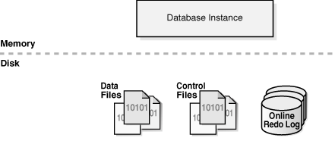

overview of  parameterfile and initialization parmaeter

Overview of Control Files

Overview of Data Files ---深入理解数据文件

Overview of the Online Redo Log  --深入理解redo

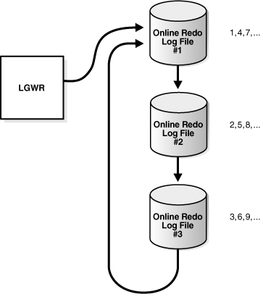

log sequence number

多路复用控制文件：放在不同的磁盘驱动器，避免io增加

[https://docs.oracle.com/cd/E11882_01/server.112/e40540/physical.htm#CNCPT003](https://docs.oracle.com/cd/E11882_01/server.112/e40540/physical.htm" \l "CNCPT003)

===========================================

》Logical Storage Structures

Oracle Database allocates logical space for all data in the database.

The logical units of database space allocation are data blocks, extents, segments, and tablespaces

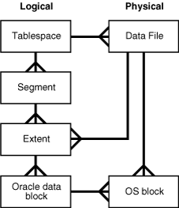

Logical Storage Hierarchy

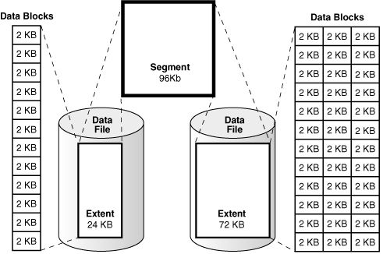

Logical Space Management

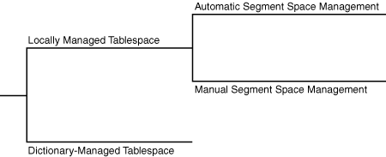

表空间管理：数据块的分配

段空间管理：数据块的使用

Locally Managed Tablespaces

The following graphic is a conceptual representation of bitmap-managed storage. A 1 in the header refers to used space, whereas a 0 refers to free space.

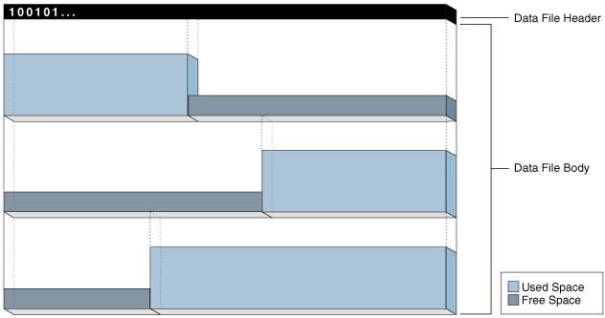

automatic segment space management (ASSM)：使用位图管理，简化管理（pctfree），增加并行

ASSM is more efficient and is the default for permanent, locally managed tablespaces.

manual segment space management (MSSM)

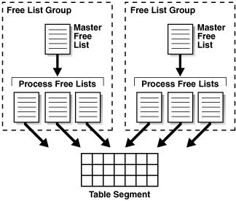

free list：记录了可用的数据块

PCTUSED：设置块的使用空间百分比（40%-60%）

如果往表中插入一行数据，数据库检查free list上的第一块，块中使用空间是否大于pctused，如果大于，则从free list上拿下，查找下一个块。

如果从表中删除一行数据，数据库检查使用空间是否小于pctused，如果是，则放在free list的开头

Oracle strongly recommends ASSM.

Dictionary-Managed Tablespaces

A dictionary-managed tablespace uses the data dictionary to manage its extents. Oracle Database updates tables in the data dictionary whenever an extent is allocated or freed for reuse

性能低

产生递归sql，占用内存空间

更改字典表，引起并发争用

Overview of Data Blocks

DB_BLOCK_SIZE initialization parameter sets the data block size for a database when it is created --不能更改，除非重建数据库

Tablespace Block Size：可以创建非默认块大小的表空间，主要用于传输表空间中

Data Block Format

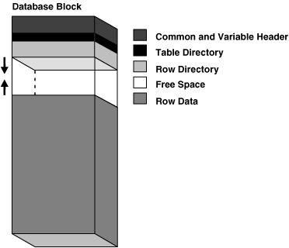

Block header：块的物理地址，所属段类型，事务槽

Table directory：对于堆表，块中行数据所属的表元数据信息，聚簇表可以将多个表的行数据存储在同一个数据块中

Row directory：对于堆表，描述了行数据的位置。行删除后，不会回收此空间，插入新行时重用

On average, the block overhead totals 84 to 107 bytes

Row Format

oracle数据库使用行管理行片段

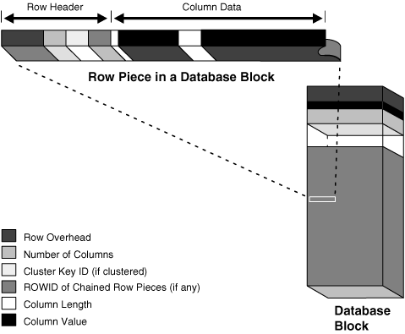

列数据按照创建表时列的顺序存放，但也有例外，long类型列最后创建，

A row fully contained in one block has at least 3 bytes of row header.

Rowid Format

Oracle Database uses a rowid to uniquely identify a row

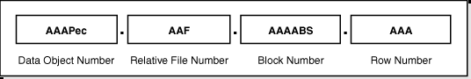

6363

An extended rowid is displayed in a four-piece format, OOOOOOFFFBBBBBBRRR, with the format divided into the following components:

OOOOOO

The data object number identifies the segment (data object AAAPec in Example 12-1). A data object number is assigned to every database segment. Schema objects in the same segment, such as a table cluster, have the same data object number.

FFF

The tablespace-relative data file number identifies the data file that contains the row (file AAF in Example 12-1).

BBBBBB

The data block number identifies the block that contains the row (block AAAABS in Example 12-1). Block numbers are relative to their data file, not their tablespace. Thus, two rows with identical block numbers could reside in different data files of the same tablespace.

RRR

The row number identifies the row in the block (row AAA in Example 12-1).

After a rowid is assigned to a row piece, the rowid can change in special circumstances. For example, if row movement is enabled, then the rowid can change because of partition key updates, Flashback Table operations, shrink table operations, and so on. If row movement is disabled, then a rowid can change if the row is exported and imported using Oracle Database utilities.

eg:

SQL> select rowid from hr.employees where employee_id=200;

ROWID

------------------

AAASbIAAFAAAADLAAC

Oracle提供了dbms_rowid plsql程序包，帮助转换rowid

SQL> desc dbms_rowid;

SELECT

    ROWID,

    dbms_rowid.rowid_object(ROWID),

    dbms_rowid.rowid_relative_fno(ROWID),

    dbms_rowid.rowid_block_number(ROWID),

    dbms_rowid.rowid_row_number(ROWID)

FROM

    hr.employees

WHERE

    employee_id = 200;

SELECT

    owner,

    segment_name,

    file_id,

    block_id,

    relative_fno,

    blocks

FROM

    dba_extents

WHERE

    owner = 'HR'

    AND segment_name = 'EMPLOYEES';

select dbms_rowid.rowid_create(1,70514,4,539,0) from dual;

Space Management in Data Blocks

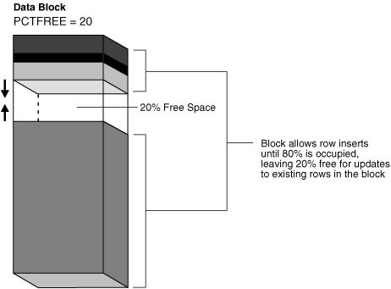

delete，update都可增加可用空间

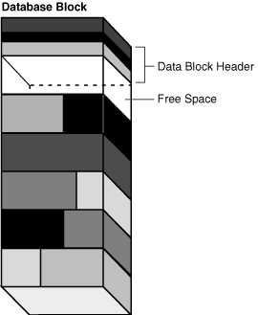

数据块碎片合并：新行插入时，找不到足够的空间时，块会自动合并碎片空间

索引块碎片合并：不会自动合并碎片空间，需要使用以下语句完成

ALTER INDEX REBUILD or COALESCE

Chained and Migrated Rows

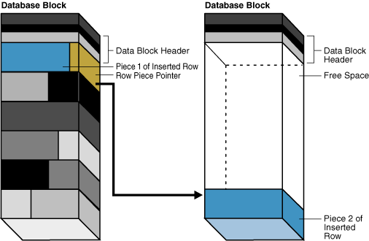

行链接：插入数据时无法容纳整个行，将行片段存储在多个块中或没有足够的空间容纳更改的行，行链接在所难免

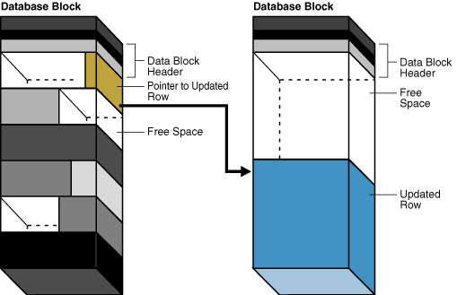

行迁移：将行数据移动到一个新的数据块上，新块足够放下整行数据。原行位置上存储指向新块的指针

超过255列时肯定会存在行链接

行链接和行迁移会增加io，降低性能，可使用段建议，回收可用空间，减少行链接和行迁移

Overview of Extents

An extent is a logical unit of database storage space allocation made up of contiguous data blocks

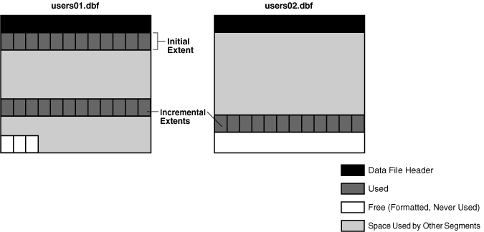

每个段都有一个初始区，区的第一个块是段头，存放有区目录（使用情况）

段的区可以来自于不同的数据文件

Deallocation of Extents

online segment shrink

move

rebuild or coalesce the index

truncate

delete不会释放区

可使用以下的sql语法手动释放区---???????????

ALTER TABLE table_name DEALLOCATE UNUSED;

而 HWM 可能存在于一个 extent 的中间某个 Block 上

|  |
| --- |
| deallocate unused 释放的是 HWM 之上的数据块。 |

Storage Parameters for Extents

order of precedence--存储参数优先级，

Segment storage clause

Tablespace storage clause

Oracle Database default

区分配-大小

uniform extents

automatically allocated extents

select tablespace_name,EXTENT_MANAGEMENT,ALLOCATION_TYPE,SEGMENT_SPACE_MANAGEMENT from dba_tablespaces;

Overview of Segments

User Segments=data segment

Table, table partition, or table cluster

LOB or LOB partition

Index or index partition

User Segment Creation

By default, the database uses deferred segment creation to update only database metadata when creating tables and indexes. Starting in Oracle Database 11g Release 2 (11.2.0.2), the database also defers segment creation when creating partitions

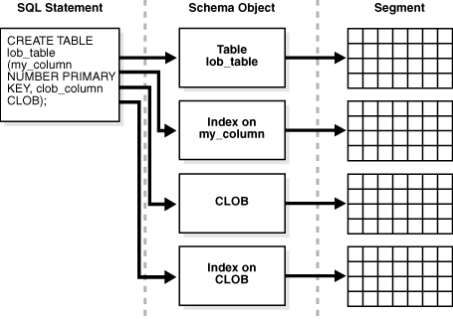

上面的语句会创建4个段

Temporary Segments

SQL语句使用排序, hashing, 或使用位图索引时，会使用临时段

创建索引时使用临时段

创临时对象（transaction or session.）时，使用临时段

[https://docs.oracle.com/cd/E11882_01/server.112/e40540/logical.htm#CNCPT004](https://docs.oracle.com/cd/E11882_01/server.112/e40540/logical.htm" \l "CNCPT004)

Undo Segments

Oracle Database maintains records of the actions of transactions, collectively known as undo data.Oracle Database uses undo to do the following:

Roll back an active transaction

Recover a terminated transaction

Provide read consistency

Perform some logical flashback operations

undo tablespace.

automatic undo management mode

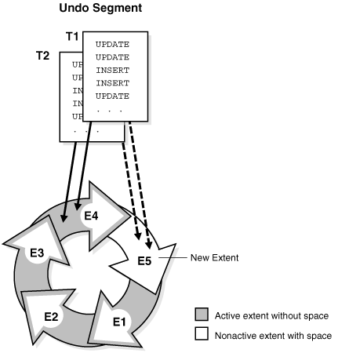

每个事务分配一个undo段，新事务分配的回滚段不能包含活动事务

如果满足条件则循环使用，如果不满足，创建新的回滚段，继续循环使用

select * from v$rollname;

select owner,EXTENT_ID,BYTES,STATUS from dba_undo_extents where segment_name='_SYSSMU6_3654194381$';

Segment Space and the High Water Mark

To manage space, Oracle Database tracks the state of blocks in the segment. The high water mark (HWM) is the point in a segment beyond which data blocks are unformatted and have never been used.

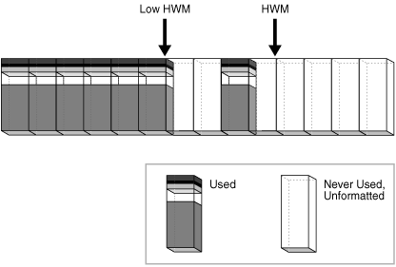

ASSM 段中的每个数据块都处于以下状态之一:

HWM 以上

未分配，这些块是未格式化的, 从未使用过。

HWM 下面

这些块位于下列状态之一:

已分配但当前未格式化和未使用

格式化并包含数据

格式化且为空, 因为数据已被删除

全表扫描会读取位图信息，找得到low HWM位置，将数据读至此位置，然后读取low HWM与HWM之前格式化使用的块

当 HWM 和低 HWM 之间的区块已满时, HWM 向右推进, LOW HWM 移到老的 HWM 的位置, HWM 继续向右推进, 低 HWM 总是尾随其后。除非手动重新生成、截断或收缩对象, 否则 HWM 从不后退。

全表扫描 ，水位线越高，io越多，性能越低

Overview of Tablespaces

A database must have the SYSTEM and SYSAUX tablespaces

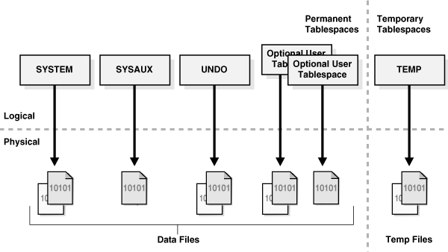

Read/Write and Read-Only Tablespaces

he SYSTEM and SYSAUX tablespaces and temporary tablespaces are permanently read/write, which means that they cannot be made read-only.

Online and Offline Tablespaces

The SYSTEM tablespace and temporary tablespaces cannot be taken offline.

Tablespace File Size

A tablespace is either a bigfile tablespace or a smallfile tablespace.

========================================

》Application Architecture

The application architecture refers to the computing environment in which a database application connects to an Oracle database. The two most common database architectures are client/server and multitier.

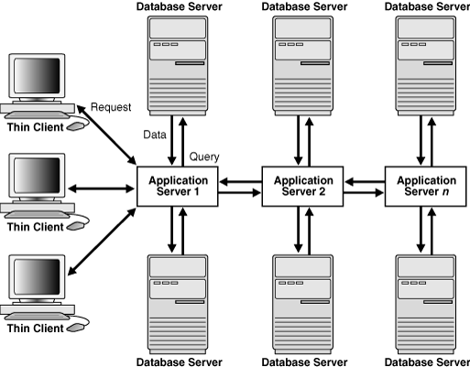

[https://docs.oracle.com/cd/E11882_01/server.112/e40540/dist_pro.htm#CNCPT702](https://docs.oracle.com/cd/E11882_01/server.112/e40540/dist_pro.htm" \l "CNCPT702)

=====================================

》Oracle Networking Architecture

--理解Oracle网络

The Oracle Net Listener

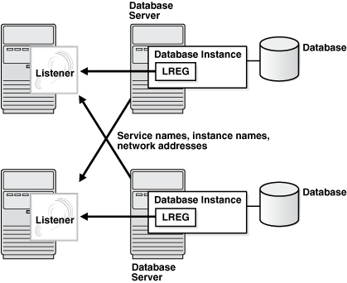

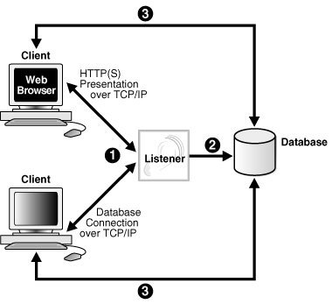

Service Registration

PMON provides the listener with information about the following:

Names of the database services provided by the database

Name of the database instance associated with the services and its current and maximum load

Service handlers (dispatchers and dedicated servers) available for the instance, including their type, protocol addresses, and current and maximum load

Dedicated Server Architecture

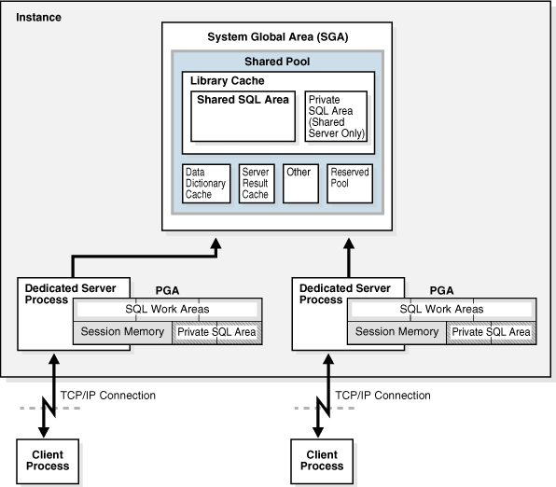

Shared Server Architecture

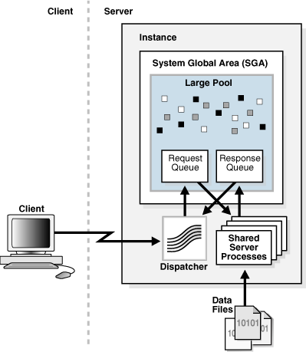

Note that a database can support both shared server and dedicated server connections simultaneously. For example, one client can connect using a dedicated server while a different client connects to the same database using a shared server.

[https://docs.oracle.com/cd/E11882_01/server.112/e40540/dist_pro.htm#CNCPT1272](https://docs.oracle.com/cd/E11882_01/server.112/e40540/dist_pro.htm" \l "CNCPT1272)

谢谢大家！